Programming Assignment: Autocomplete Me
Write a program to implement autocomplete for a given set of N strings and positive weights. That is, given a prefix, find all strings in the set that start with the prefix, in descending order of weight.
Autocomplete is an important feature of many modern applications. As the user types, the program predicts the complete query (typically a word or phrase) that the user intends to type. Autocomplete is most effective when there are a limited number of likely queries. For example, the Internet Movie Database uses it to display the names of movies as the user types; search engines use it to display suggestions as the user enters web search queries; cell phones use it to speed up text input.
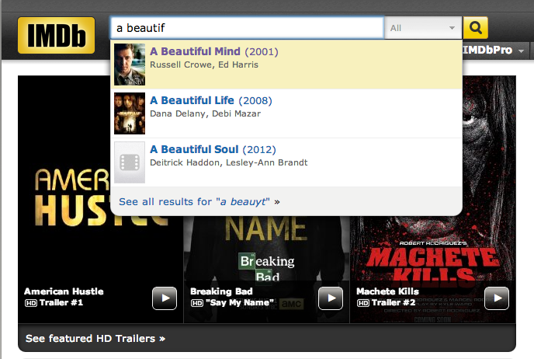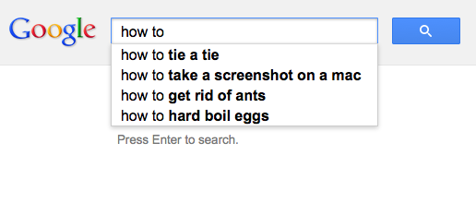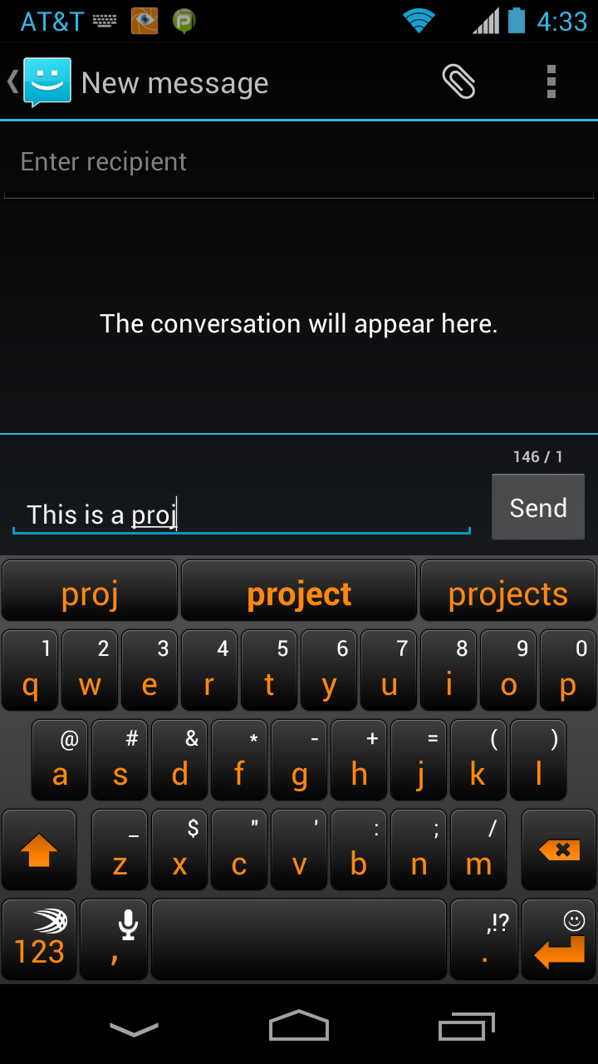
In these examples, the application predicts how likely it is that the user is typing each query and presents to the user a list of the top-matching queries, in descending order of weight. These weights are determined by historical data, such as box office revenue for movies, frequencies of search queries from other Google users, or the typing history of a cell phone user. For the purposes of this assignment, you will have access to a set of all possible queries and associated weights (and these queries and weights will not change).
The performance of autocomplete functionality is critical in many systems. For example, consider a search engine which runs an autocomplete application on a server farm. According to one study, the application has only about 50ms to return a list of suggestions for it to be useful to the user. Moreover, in principle, it must perform this computation for every keystroke typed into the search bar and for every user!
In this assignment, you will implement autocomplete by sorting the queries in lexicographic order; using binary search to find the set of queries that start with a given prefix; and sorting the matching queries in descending order by weight.
Part 1: autocomplete term. Write an immutable data type Term.java that represents an autocomplete term: a string query and an associated real-valued weight. You must implement the following API, which supports comparing terms by three different orders: lexicographic order by query string (the natural order); in descending order by weight (an alternate order); and lexicographic order by query string but using only the first r characters (a family of alternate orderings). The last order may seem a bit odd, but you will use it in Part 3 to find all terms that start with a given prefix (of length r).
public class Term implements Comparable<Term> {

// Initialize a term with the given query string and weight.
public Term(String query, double weight)

// Compare the terms in descending order by weight.
public static Comparator<Term> byReverseWeightOrder()

// Compare the terms in lexicographic order but using only the first r characters of each query.
public static Comparator<Term> byPrefixOrder(int r)

// Compare the terms in lexicographic order by query.
public int compareTo(Term that)

// Return a string representation of the term in the following format:
// the weight, followed by a tab, followed by the query.
public String toString()
}
The constructor should throw a java.lang.NullPointerException if query is null and a java.lang.IllegalArgumentException unless weight is nonnegative. The byPrefixOrder() method should throw a java.lang.IllegalArgumentException if r is negative.
Part 2: binary search. When binary searching a sorted array that contains more than one key equal to the search key, the client may want to know the index of either the first or the last such key. Accordingly, implement the following API:
public class BinarySearchDeluxe {

// Return the index of the first key in a[] that equals the search key, or -1 if no such key.
public static <Key> int firstIndexOf(Key[] a, Key key, Comparator<Key> comparator)

// Return the index of the last key in a[] that equals the search key, or -1 if no such key.
public static <Key> int lastIndexOf(Key[] a, Key key, Comparator<Key> comparator)
}
Corner cases. Each static method should throw a java.lang.NullPointerException if any of its arguments is null. You should assume that the argument array is in sorted order (with respect to the supplied comparator).
Performance requirements. The firstIndexOf() and lastIndexOf() methods should make at most 1 + ⌈log2 N⌉ compares in the worst case,
Part 3: autocomplete. In this part, you will implement an immutable data type that provides autocomplete functionality for a given set of string and weights, using Term and BinarySearchDeluxe. To do so, sort the terms in lexicographic order; use binary search to find the set of terms that start with a given prefix; and sort the matching terms in descending order by weight. Organize your program by creating an immutable data type Autocomplete with the following API:
public class Autocomplete {

// Initialize the data structure from the given array of terms.
public Autocomplete(Term[] terms)

// Return all terms that start with the given prefix, in descending order of weight.
public Term[] allMatches(String prefix)

// Return the number of terms that start with the given prefix.
public int numberOfMatches(String prefix)
}
Corner cases. The constructor and each method should throw a java.lang.NullPointerException its argument is null.
Performance requirements. The constructor should make proportional to N log N compares (or better) in the worst case, where N is the number of terms. The allMatches() method should make proportional to log N + M log M compares (or better) in the worst case, where M is the number of matching terms. The numberOfMatches() method should make proportional to log N compares (or better) in the worst case. In this context, a compare is one call to any of the compare() or compareTo() methods defined in Term.
Input format. We provide a number of sample input files for testing. Each file consists of an integer N followed by N pairs of query strings and positive weights. There is one pair per line, with the weight and string separated by a tab. A query string can be an arbitrary sequence of Unicode characters, including spaces (but not newlines).
- The file wiktionary.txt contains the 10,000 most common words in Project Gutenberg, with weights equal to their frequencies.
- The file cities.txt contains over 90,000 cities, with weights equal to their populations.
% more wiktionary.txt  10000  56271872.00 the  33950064.00 of  29944184.00 and  25956096.00 to  17420636.00 in  11764797.00 i  11073318.00 that  10078245.00 was  8799755.00 his  ...  3923.23 calves | % more cities.txt  93827  14608512 Shanghai, China  13076300 Buenos Aires, Argentina  12691836 Mumbai, India  12294193 Mexico City, Distrito Federal, Mexico  11624219 Karachi, Pakistan  11174257 İstanbul, Turkey  10927986 Delhi, India  10444527 Manila, Philippines  10381222 Moscow, Russia  ...  2 Al Khāniq, Yemen
Below is a sample client that takes the name of an input file and an integer k as command-line arguments. It reads the data from the file; then it repeatedly reads autocomplete queries from standard input, and prints out the top k matching terms in descending order of weight.
public static void main(String[] args) {

// read in the terms from a file
String filename = args[0];
In in = new In(filename);
int N = in.readInt();
Term[] terms = new Term[N];
for (int i = 0; i < N; i++) {
double weight = in.readDouble(); // read the next weight
in.readChar(); // scan past the tab
String query = in.readLine(); // read the next query
terms[i] = new Term(query, weight); // construct the term
}

// read in queries from standard input and print out the top k matching terms
int k = Integer.parseInt(args[1]);
Autocomplete autocomplete = new Autocomplete(terms);
while (StdIn.hasNextLine()) {
String prefix = StdIn.readLine();
Term[] results = autocomplete.allMatches(prefix);
for (int i = 0; i < Math.min(k, results.length); i++)
StdOut.println(results[i]);
}
}
Here are a few sample executions:
% java Autocomplete wiktionary.txt 5  auto  6197.0 automobile  4250.0 automatic  comp  133159.0 company  78039.8 complete  60384.9 companion  52050.3 completely  44817.7 comply  the  56271872.0 the  3340398.0 they  2820265.0 their  2509917.0 them  1961200.0 there |  | % java Autocomplete cities.txt 7  M  12691836.0 Mumbai, India  12294193.0 Mexico City, Distrito Federal, Mexico  10444527.0 Manila, Philippines  10381222.0 Moscow, Russia  3730206.0 Melbourne, Victoria, Australia  3268513.0 Montréal, Quebec, Canada  3255944.0 Madrid, Spain  Al M  431052.0 Al Maḩallah al Kubrá, Egypt  420195.0 Al Manşūrah, Egypt  290802.0 Al Mubarraz, Saudi Arabia  258132.0 Al Mukallā, Yemen  227150.0 Al Minyā, Egypt  128297.0 Al Manāqil, Sudan  99357.0 Al Maţarīyah, Egypt
Interactive GUI (optional, but fun and no extra work). Download and compile AutocompleteGUI.java. The program takes the name of a file and an integer k as command-line arguments and provides a GUI for the user to enter queries. It presents the top k matching terms in real time. When the user selects a term, the GUI opens up the results from a Google search for that term in a browser.
% java AutocompleteGUI cities.txt 10
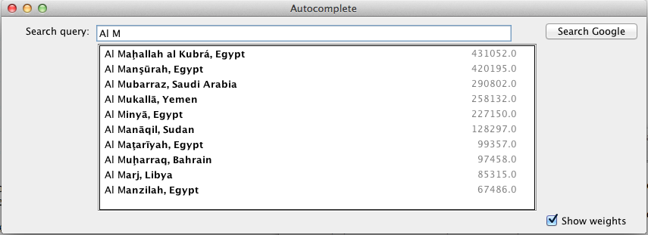
Extra credit 1. This is an opportunity to earn extra credit and contribute to future offerings of this assignment. Create a real-world data (preferably large or huge) for which autocomplete would be appropriate and document it in your readme file (including a reference to the original data source). Below are a few possibilities. Note that some of the datasets are massive and you will need to filter them down to appropriate sizes and put them into our file format.
- Wikipedia: term = Wikipedia page, weight = number of hits per year.
- Google books Ngram Viewer: term = n-gram, weight = frequency of occurrence in corpus of books.
- Wiktionary: term = word, weight = frequency of occurrence in corpus. Pick a language with a non-Latin alphabet such as Hebrew, Arabic, Russian, Greek, or Japanese.
- The Internet Movie Database: term = movie, weight = number of reviews or average rating.
Be sure that your file is in the prescribed format (tab-separated and UTF-8 encoded). If your file is less than 50MB, submit it as usual; if it is larger, please contact your preceptor for submission instructions.
Extra credit 2. Improve AutcompleteGUI.java in the following (or other) ways:
- Improve the graphical layout (e.g., align search bar and suggestion box, allow search bar and suggestion box to expand to width of window).
- Fix some of the known bugs, which are documented in the file.
Deliverables. Submit Autocomplete.java, BinarySearchDeluxe.java, and Term.java. Your may not call any library functions other than those in java.lang, java.util, stdlib.jar, and algs4.jar. Finally, submit a readme.txt file and answer the questions.
This assignment was developed by Matthew Drabick and Kevin Wayne.
Copyright © 2014.

